BCIS-5420 Assignment-2

(50+1 points)

**Tool Introduction for Hands on queries:**

Use Oracle APEX (Application Express) to create and use a demo database for a college – College Database – as follows:

1. Open [APEX login](https://apex.oracle.com/en/learn/getting-started) page and get Free workspace. Please write down your Workspace Name, User and Password

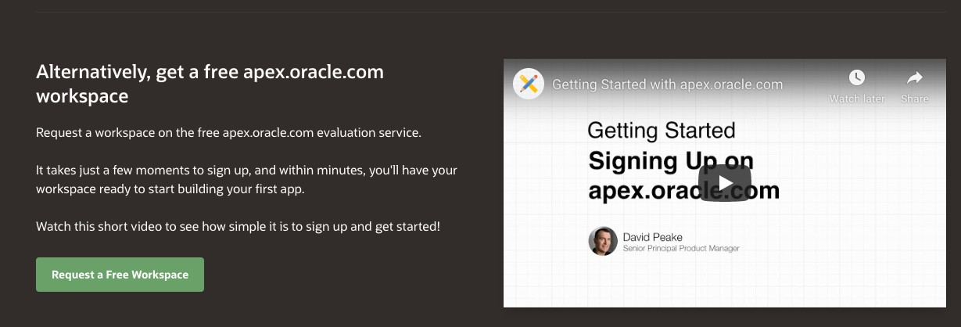

APEX Sign-in screen


1. Once you’re logged in successfully, you’ll see the following APEX window:

APEX window


1. Open **SQL Workshop**.

APEX Window


Open **SQL Scripts** to upload and run the provided SQL scripts – (1) CreateTables.sql to create tables and

(2) InsertRecords.sql to insert records. These script files have been saved in your Dropbox folder in the folder named SQL Scripts.

List of Uploaded Script in SQL Workkshop.


1. 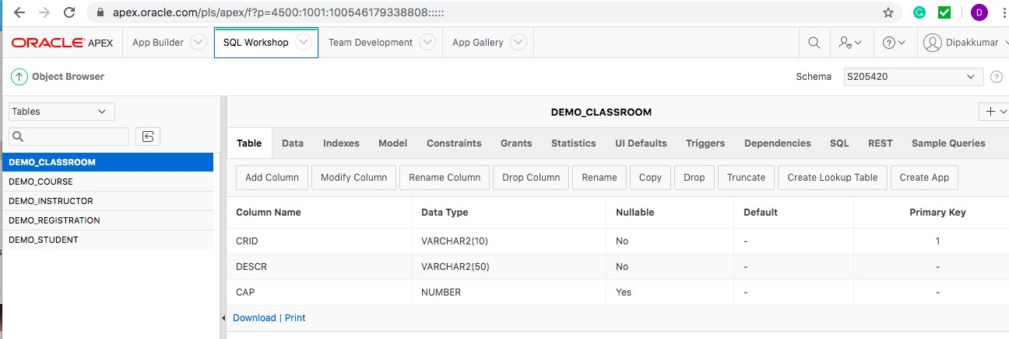Open SQL Workshop Object Browser to view the tables created in Step 5. Make sure all five tables have been created as shown below.
2. Open SQL Workshop →**SQL Commands** and write and run a query for each table to show the content of the table. Save each query using a name like “**Show Table\_Name**” (e.g., **Show Student**).

Results of an SQL statement "Select * FROM DEMO_STUDENT" is shown.


1. Alternatively, one can use Open SQL Workshop →**Utilities** and the **Query Builder** and create and run a queries.

**Instructions:**

1. Get a **PDF** file of all your queries and submit the PDF on canvas.
2. Only onesubmission required per team**.**
3. Must mention the below info in the cover page document.
   1. SQL Workspace name
   2. User ID
   3. Date
   4. Team members names with student id.
4. Please note that you may be asked to prove that you have created and executed scripts in your account, so do not delete or update the scripts that you have submitted.
5. Each question carries 3 points, for a total of 51 points. You can write a query, however, you like but it must give the correct results.
6. Response to each question must be clearly labeled as ‘Query01’, ‘Query02’ etc,
7. Response to each question must be show as the example below:

Query: SELECT \* FROM DEMO\_INSTRUCTOR;

Result:

|  |  |  |
| --- | --- | --- |
| **IID** | **NAME** | **DEPT** |
| I01 | Becker | BCIS |
| I02 | Lee | Computer |
| I03 | Ferguson | English |
| I04 | Harvey | Statistics |
| I05 | Koh | BCIS |
| I06 | Kent | Economics |

* 6 rows selected. 0.01 seconds

**SQL code must be submitted for the below questions as response to this assignment:**

1. Retrieve all the columns from each table listed below, using select statement. Save the query as ‘Q1\_Select for all’.

demo\_classroom, demo\_course, demo\_instructor, demo\_registration, demo\_student

1. Show Name, Year and GPA of all business major students in descending order of Year. Do not show Major. Save the query as ‘Q2\_Business Majors.
2. Show Course ID, Course Title and Classroom for all courses taught by instructor ‘I06’. Save the query as ‘Q3\_Courses\_by\_I06’.
3. Show Course ID, Course Title and Description (Classroom table) and Capacity (Classroom table) of all courses that meets in ‘Curry 205’. Save the query as ‘Q4\_Courses in Curry 205’.
4. Retrieve the instructor ID who teaches more than one course from the table ‘demo\_course’. Save the query as ‘Q5\_MultiCourse’.
5. Retrieve all the columns from ‘demo\_course’ only when the instructor (instructor ID) who teaches more than one course and their teaching course related to ‘business’ or ‘course credit hour’ not more than 2 hours. Save the query as ‘Q6\_BusinessCourse’.
6. Retrieve the Name and Dept from the table ‘demo\_instructor’ only when the instructor teaches exactly one course. Save the query as ‘Q7\_SingleCourse’.
7. Retrieve the CID, Count in which No.of students enrolled for each course from the table ‘demo\_registration’. Save the query as ‘Q8\_CourseRegistration’.
8. Retrieve all the columns from the table ‘demo\_course’ only when more than 4 students enrolled for each course. Save the query as ‘Q9\_MaxCourseRegistration’.
9. Retrieve all the columns from the table demo\_classroom such as values of CRID and DESCR should be unique only when the classroom capacity are same b/w classes. Save the query as ‘Q10\_RoomCapacity’.
10. Create a temporary table, name it as ‘Temp\_Q10\_Result’ to capture the results of Question10. Save the query as ‘Q11\_TempStructure’.
11. Retrieve the Year, Avg GPA of students on yearly manner with ascending order. (ex. What is the avg GPA for 1st,2nd ,3rd,4th year students etc). Save the query as ‘Q12\_YearlyGPA’.
12. Retrieve the Year, Avg GPA of students, rownumber from demo\_student and apply rownumber function for each row in ascending order based on the column avg GPA. Save the query as ‘Q13\_RowID\_with\_ YearlyGPA’.

(ex. What is the avg GPA,row\_number for 1st,2nd ,3rd,4th year students etc). Save the query as ‘Q13\_Row numbers’.

1. By using the result of the Question 13, Identify which YEAR having the lowest avg GPA. Result set should contain the columns YEAR, Avg GPA. Save the query as ‘Q14\_LowestYearlyGPA’.
2. Retrieve all the columns from the table ‘demo\_student’ for the 1st year students who are having lowest GPA (GPA <2). Save the query as ‘Q15\_LowGPA\_Students’.
3. Get the CID, SID from the demo\_registration for the students whose major is ‘Computer’. Save the query as ‘Q16\_ComputerRelatedCourse’.
4. Retrieve course info(all columns) from demo\_course only for the students whose major is ‘Computer. Save the query as ‘Q17\_Computer\_Courses’.